Lab: GitHub
Submitted by Robert Colacci

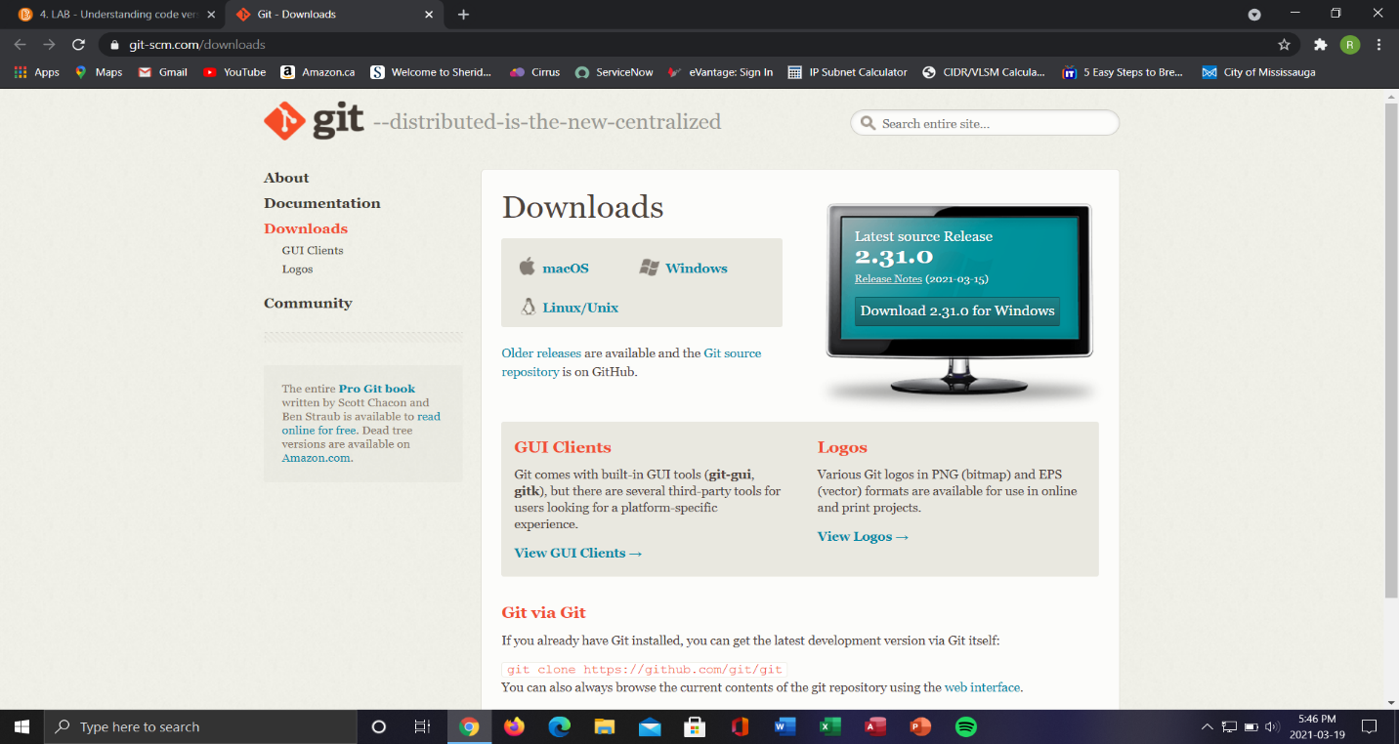
Go to https://git-scm.com/downloads to download and install git onto your device. Choose the version that fits your specifications. 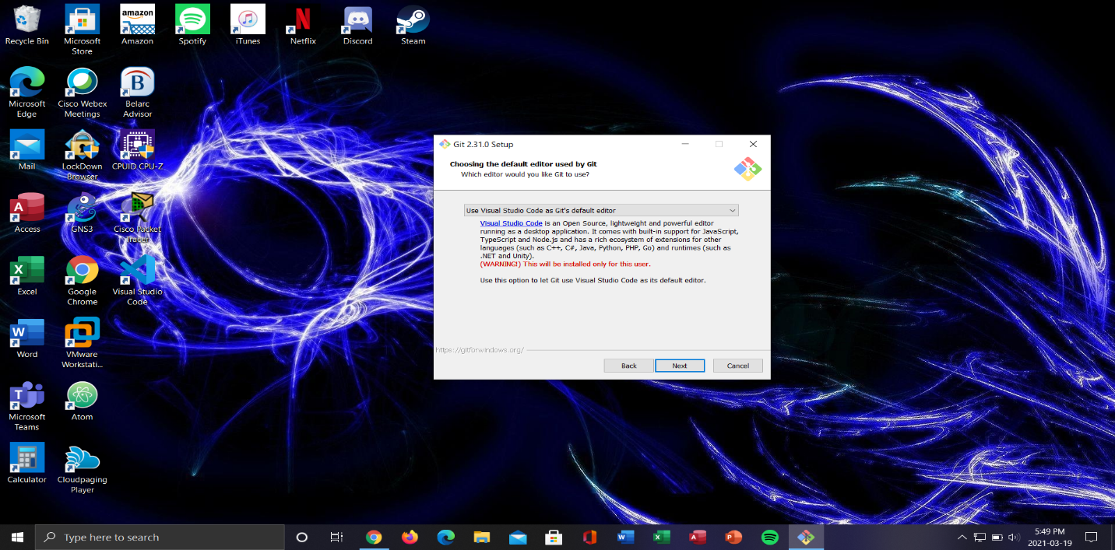
Select all of the default options in the setup wizard and choose “Use Virtual Studio Code as Git’s default editor”.
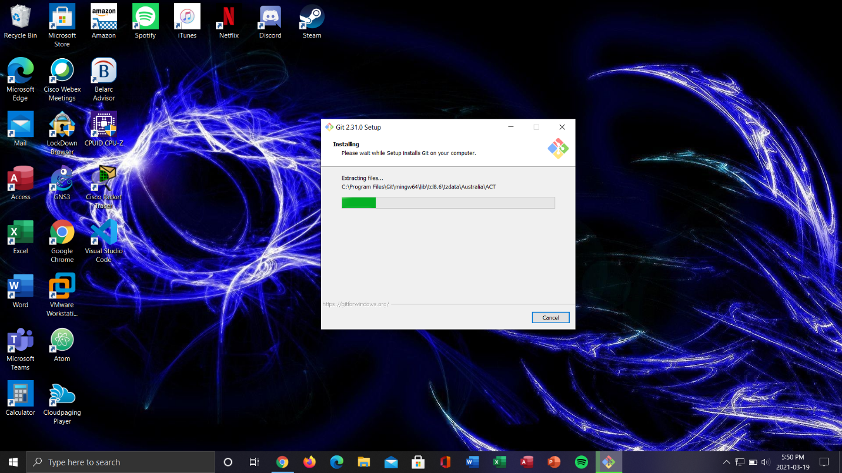
Now wait for the installation process, this may take a few minutes.

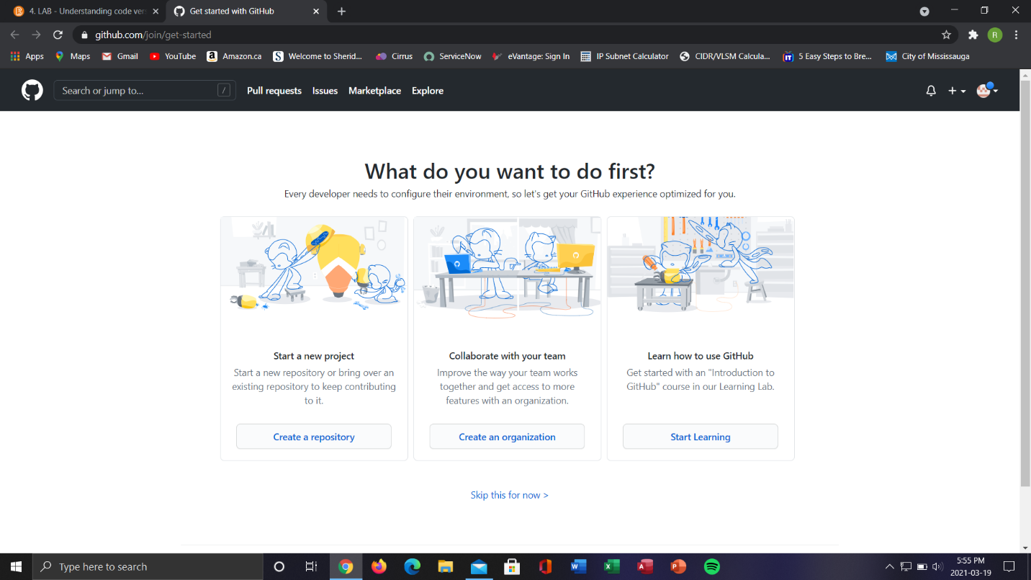
Go to www.GitHub.com and create an account if you do not have one already.
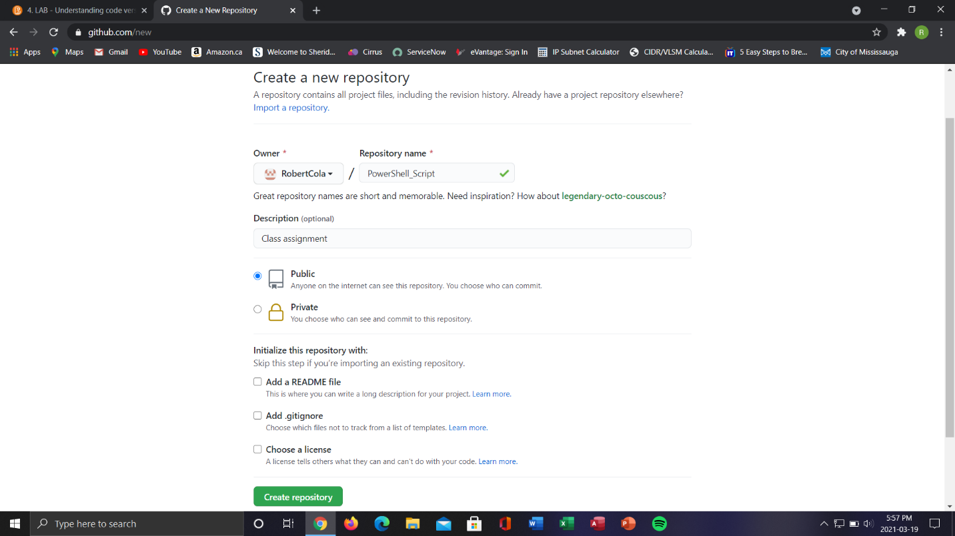
Once you have created your account Create a new repository and call it PowerShell_Script.

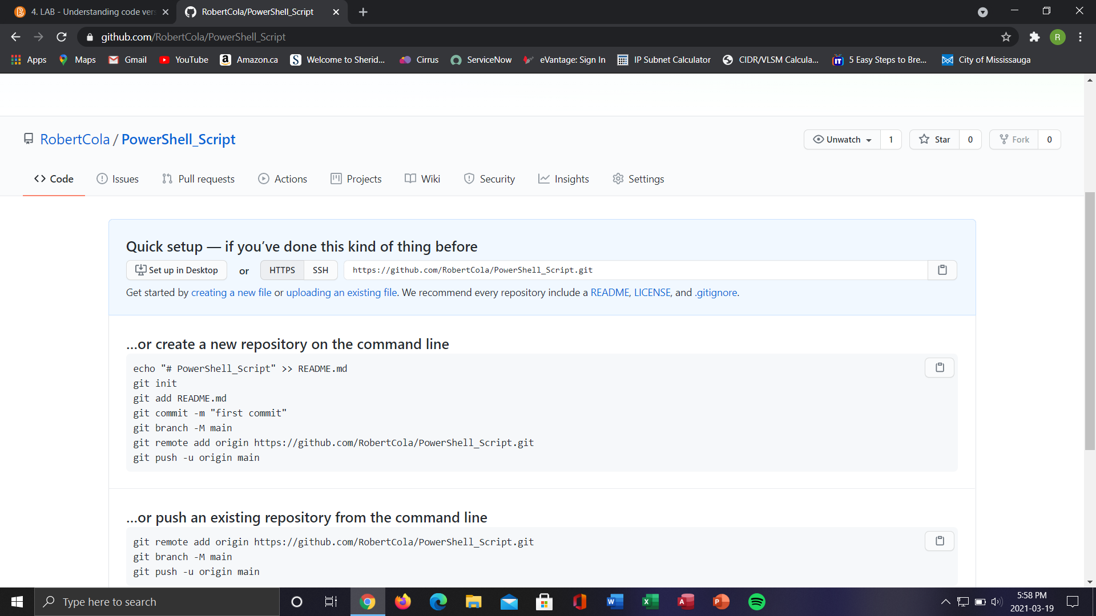
Copy the link to your repository.
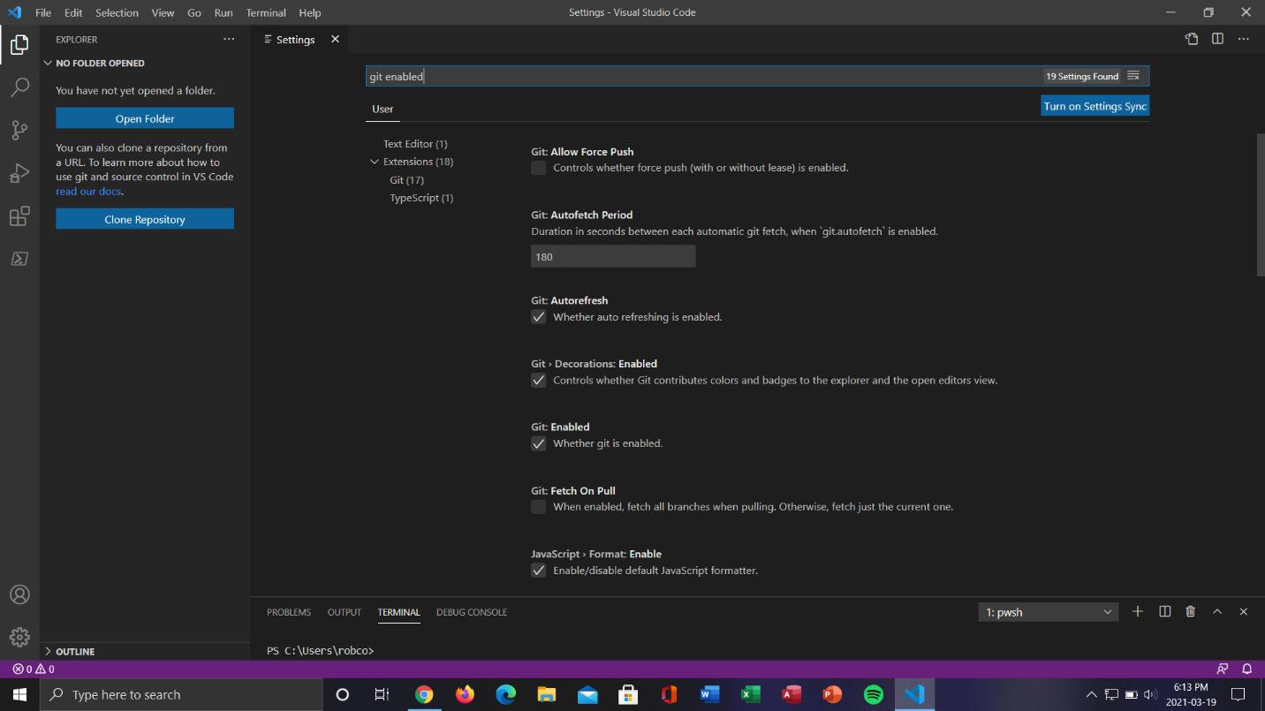
Open VS Code and go to the settings are make sure that Git is enabled.

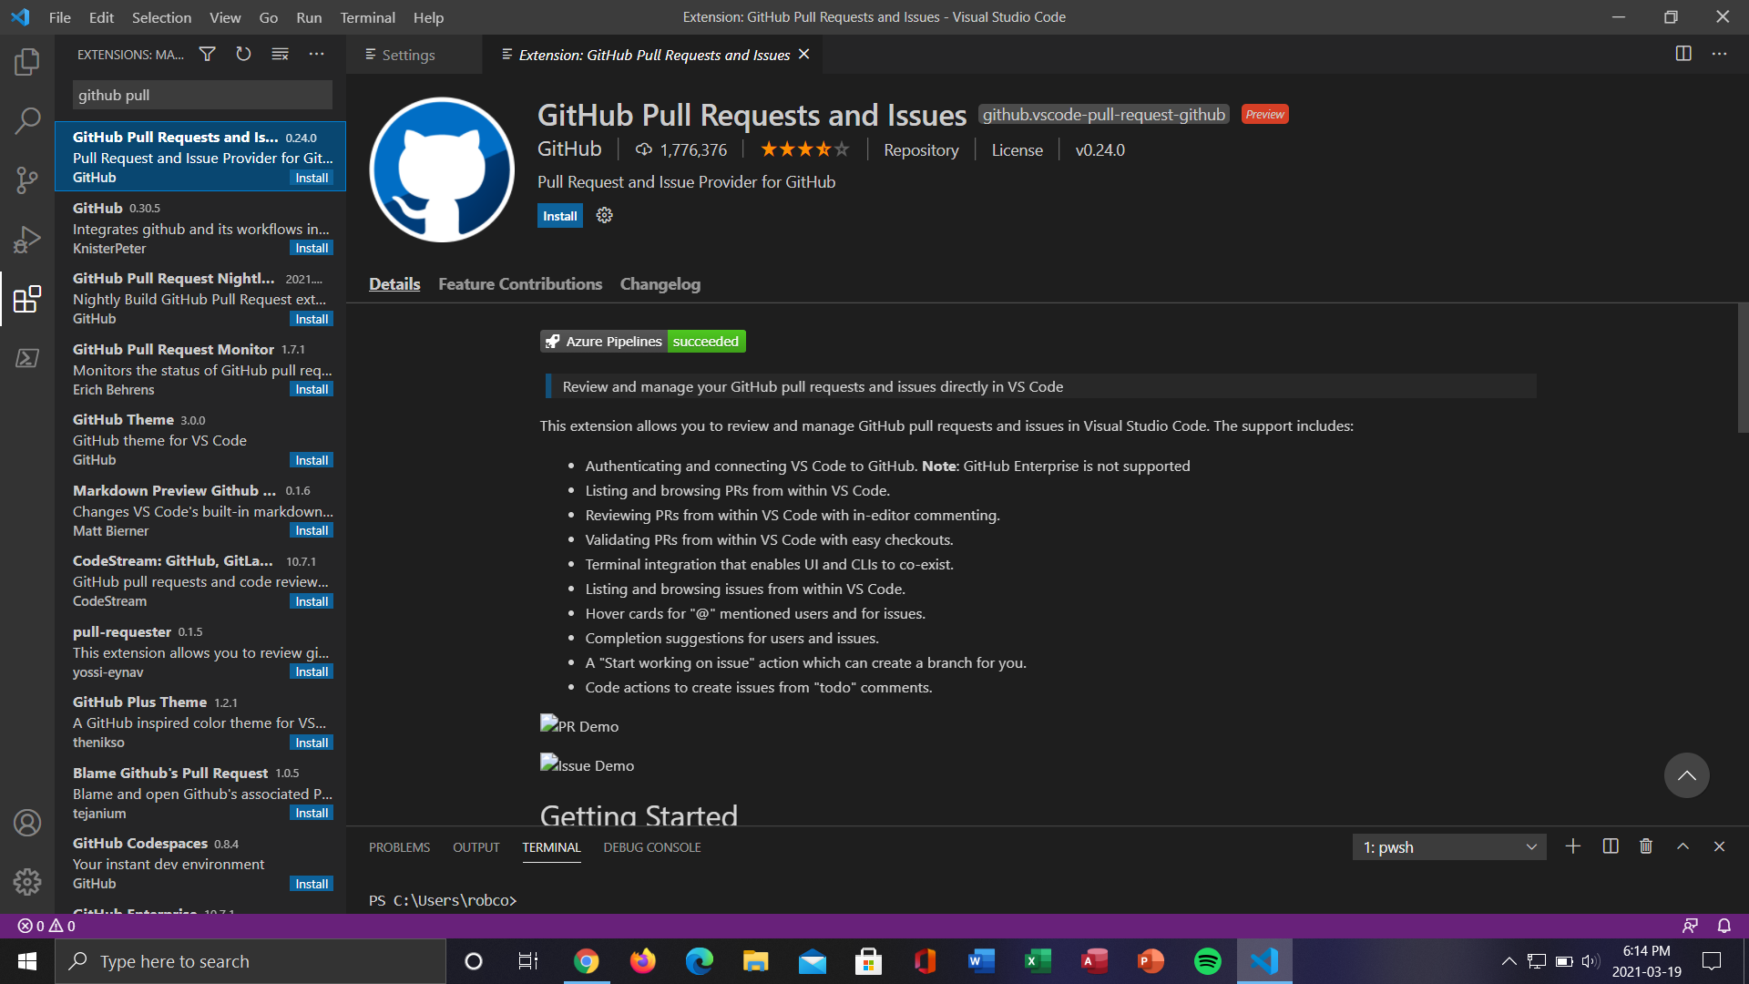
Click the Extensions tab, search for GitHub Pull Requests and Issues and install it.
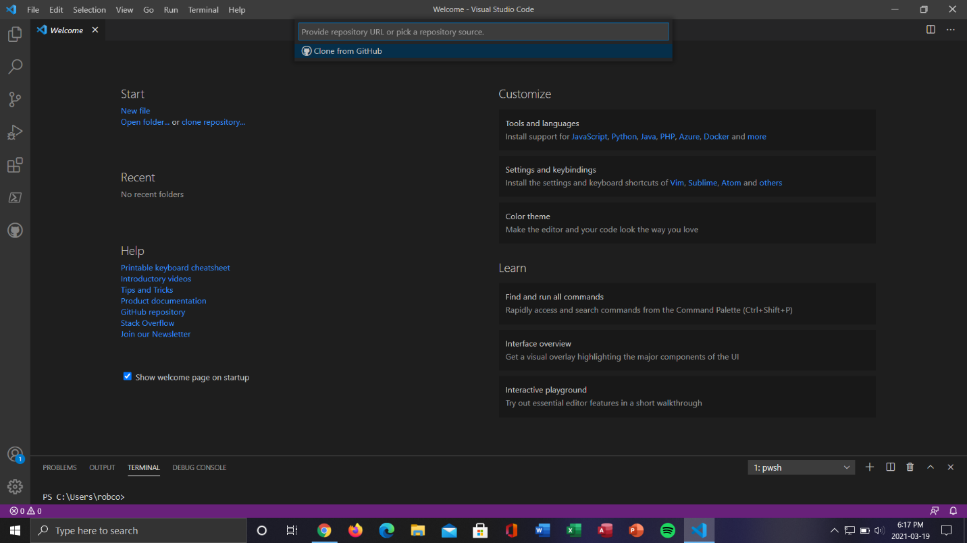
On the start menu choose clone repository and follow the steps.

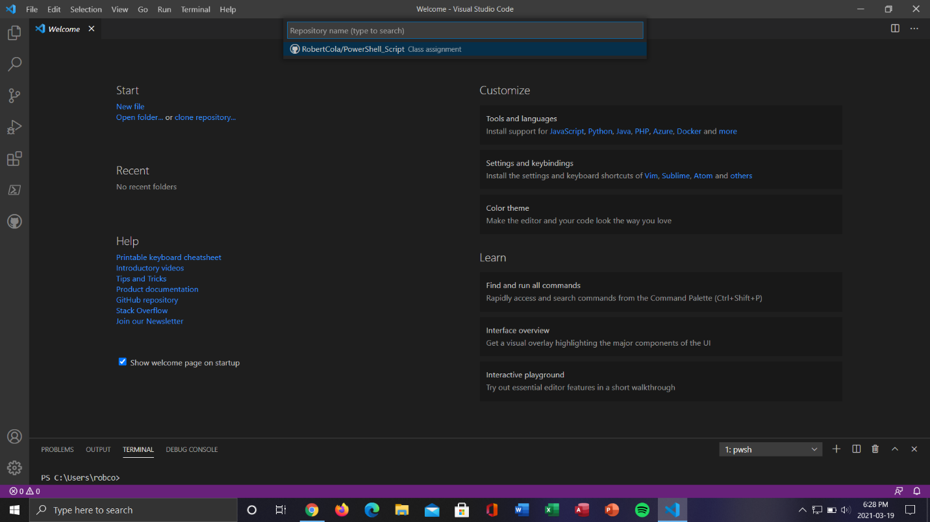
Once you sign into your GitHub account and allow permissions, you will be able to pull up the repositories that you have saves on Github.com.

